Ideation Phase
Define the Problem Statements
Date | 20 July 2026
Team ID
Project Name | Nutrition Assistant using MERN Stack
Maximum Marks | 2 Marks

Customer Problem Statement Template:
Create a problem statement to understand your customer's point of view. The Customer Problem Statement template helps you focus on what matters to create experiences people will love.
A well-articulated customer problem statement allows you and your team to find the ideal solution for the challenges your customers face. Throughout the process, you’ll also be able to empathize with your customers, which helps you better understand how they perceive your product or service.
Example:
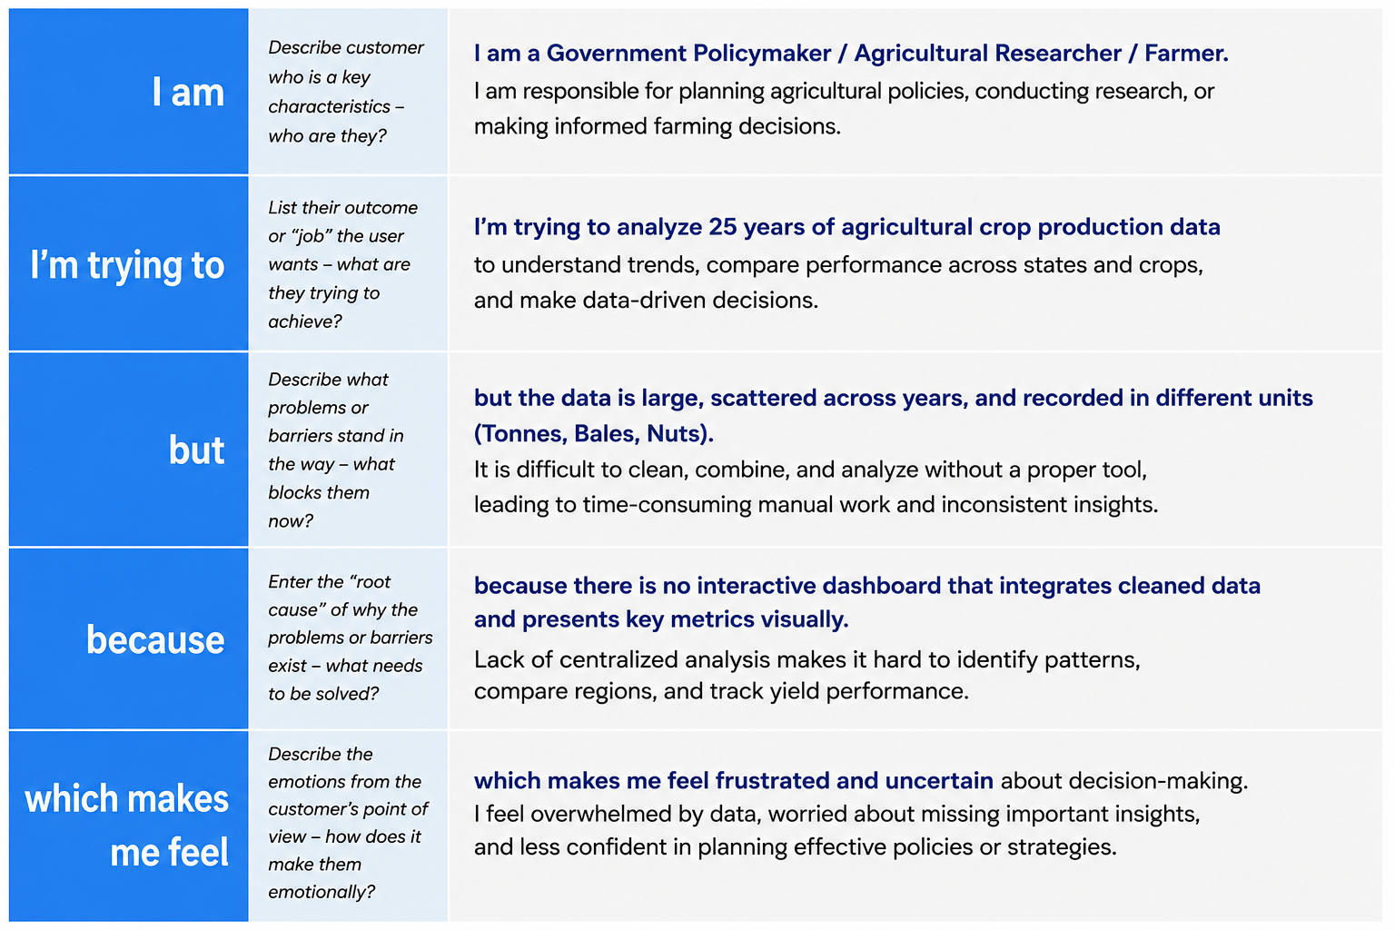
Reference: https://miro.com/templates/customer-problem-statement/
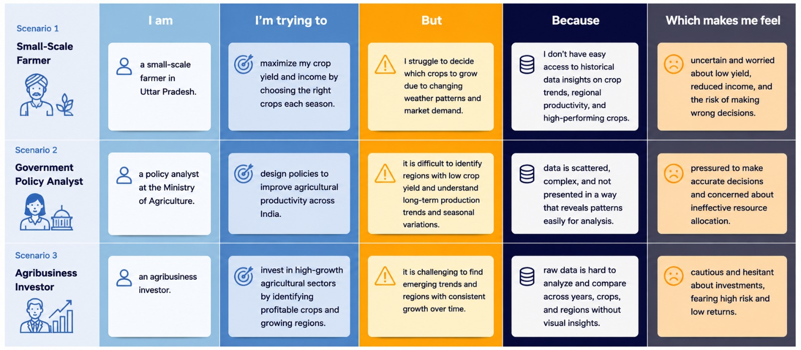
Problem  Statement (PS) | I am  (Customer) | I’m trying to | But | Because | Which makes me feel
PS-1 | A Working Professional | maintain a healthy diet and track my daily calorie and nutrient intake | I end up manually cross-checking food values across multiple websites and still get inconsistent numbers | there is no single platform that calculates my BMI, tracks my nutrition, and recommends meals based on my goals | discouraged and likely to abandon my health goals altogether
PS-2 | A Fitness Enthusiast | follow a diet plan that matches my calorie and macro requirements for weight loss or muscle gain | generic diet charts don't account for my personal BMI, activity level, or food preferences | I lack access to an AI-powered system that gives personalized meal recommendations and tracks my daily progress | frustrated and unsure whether I'm actually progressing toward my fitness goals

